

STUDENT CASE STUDY EXECUTION

Department | FED
Subject | DSA-2
Academic Year | I-III Semester (2025-26)
Faculty Name | Mamatha
Student Name | K.Siri Chandana
Roll Number | 2520030453
Branch | CSE
Course Outcome | CO4

Case Study Topic : Smart Banking System: Optimizing Transaction Routing Between Bank Branches and ATMs Using Shortest Path Algorithms

Work Done Summary:

In this case study, we developed a Smart Banking System that models bank branches and ATMs as nodes in a graph. The communication links between them are represented as weighted edges based on network latency or transaction processing cost.
The system uses:
- Dijkstra's Algorithm to find the fastest route between a branch and an ATM.
- Bellman-Ford Algorithm to handle routes with varying transaction costs and detect negative-weight cycles.
- Floyd-Warshall Algorithm to compute shortest paths between all branches and ATMs.
This helps the bank route transactions efficiently, reduce processing delays, and improve network reliability.

Implementation Details:

• Represented branches and ATMs as graph vertices.
• Added weighted edges representing transaction processing cost.
• Implemented Dijkstra's algorithm for single-source shortest path.
• Implemented Bellman-Ford algorithm for graphs with negative weights.
• Implemented Floyd-Warshall algorithm for all-pairs shortest paths.
• Compared results and analyzed performance.
• Identified the optimal transaction routes across the banking network.
Result: Screenshots / Output
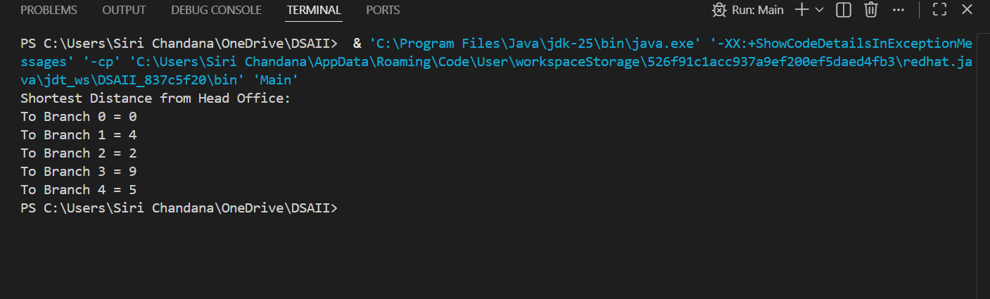

Conclusion
The Smart Banking System successfully used Dijkstra's Algorithm to determine the shortest transaction routes between bank branches. This reduced communication costs and improved transaction processing efficiency across the banking network. The study demonstrates how graph-based shortest path algorithms can enhance the performance and reliability of modern banking systems.

GitHub Link: https://github.com/ksirichandana007-cmyk/Smart-Banking-System.git

Student Signature | Faculty Signature

